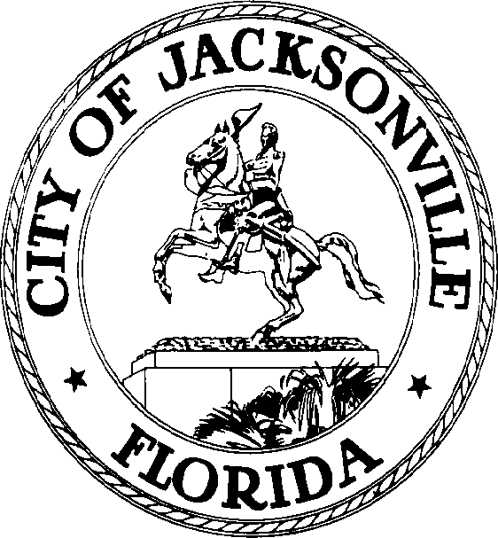

SAM C. NEWBY  Council President Group 5, At-Large  E-Mail: snewby@coj.net | OFFICE OF THE CITY COUNCIL | 117 West Duval Street City Hall, Suite 425  Jacksonville, Florida 32202  Office (904) 255-5219  Fax (904) 255-5230

FOR IMMEDIATE RELEASE
FEBRUARY 25, 2022

Nick Howland Election Certified – Group 3, At-Large Jacksonville City Council

JACKSONVILLE, Fla. - The Duval County Supervisor of Elections certified the Group 3, At-Large Election Results. This action attests that the Honorable Nick Howland, Council Member-Elect, is the official representative for Group 3, At-Large, Jacksonville City Council. The Honorable Nick Howland, Council Member-Elect, will serve as representative until June 30, 2023.

The Swearing-In Ceremony is on Wednesday, March 2, 2022, at 12:00 P.M., at City Hall St. James Building, Council Chamber, located at 117 West Duval Street, Jacksonville, Florida.

The Honorable Nick Howland, Council Member-Elect, will serve on the Neighborhoods, Community Services, Public Health and Safety (NCSPHS) Committee, and the Rules Committee.

"I would like to personally congratulate Nick and welcome him to the Jacksonville City Council.", Honorable Sam Newby, City Council President.

Pursuant to the American with Disabilities Act, accommodations for persons with disabilities are available upon request. Please allow 1-2 business days' notification to process; last-minute requests will be accepted but may not be possible to fulfill. Please contact Disabled Services Division at: V (904) 255-5466, TTY (904) 255-5476, or email your request to KaraT@coj.net.

Contact: Yvonne P. Mitchell (904) 255-5171

